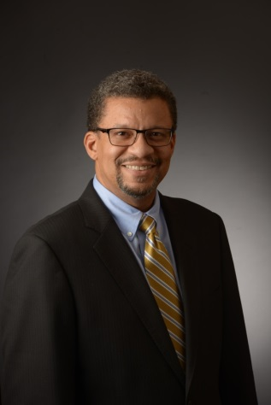 Joe Machicote is the Senior Vice President of Human Resources and Chief Diversity Officer for Erickson Living. In this role, Joe is responsible for all aspects of HR and culture development throughout the enterprise, which include creating high performing teams, workforce planning, rewards and recognition, succession planning, employee relations, learning & organizational development, talent acquisition, policy and procedure, payroll, compensation and benefits. Joe has over 25 years of experience working in HR and has held several leadership and hospitality roles throughout his career.
Prior to joining the Erickson Living team, Joe was the Vice President of HR & Organizational Development and Chief Diversity Officer at Snyder's-Lance, a leading manufacturer of snack foods. In that role, he was responsible for leading the company's HR functions, as well as developing an organizational culture that emphasized character, capability, and diversity. Additionally, Joe served in several leadership positions with Compass Group. His roles included Chief Diversity Officer, Vice President of Relations Development, Division Director of HR, Director of HR and Training, and Director of Foodservice and Dining Operations. Joe has also led and sat on several Community Boards following his passion for education, culture, diversity and inclusion and the advancement of under-privileged and at-risk individuals.
Joe holds a Bachelor of Arts in Business Marketing from Manhattanville College.

