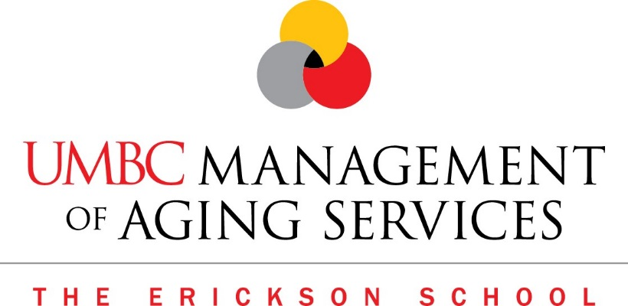

Frequently Asked Questions (FAQ)
What is UMBC?
U.S. News & World Report ranks UMBC (University of Maryland Baltimore County) as # 7 of its Most Innovative Schools list. Princeton Review highlighted UMBC’s welcoming environment and reputation for valuing the perspectives that diverse, creative minds can bring to the classroom, research lab, and art studio.

UMBC is part of the University of Maryland System, and is located in Baltimore (Catonsville) approximately 8 miles from the Baltimore/Washington International Airport. Its 500-acre campus is 15 minutes from Baltimore’s Inner Harbor and 30 minutes from Washington D.C. Current enrollment is 13,662 students, including 2,428 graduate students.

How challenging is the M.A. in Management of Aging Services?
It is a very challenging - and very rewarding - graduate program that leads to great job opportunities and advancement in a dynamic and growing profession. Students indicate that they spend about 2 hours outside of class for every hour in class, on average. The online courses average about 5-6 hours per week. It is well worth the time and effort!

How are the courses and content delivered?
The Management of Aging Services graduate program is a hybrid program, meaning that some of the content is offered online, and some of the content is delivered in the classroom.

How much of the program is online and how much is in the classroom?
The amount of course content offered online and in the classroom varies by semester. Check current semester and course requirements for specific details.

Are some courses a combination of both classroom & online?
The Management of Aging Services graduate program is a dynamic experience, and yes, some of the courses include both classroom and online content. In addition, the program includes both synchronous and asynchronous online content.

The program also features some group work, so you’ll get to work with other professionals and students along the way, both online and in person.

How many campus visits per semester?
The number of classroom visits varies by semester, but generally can be between no visits and up to approximately 10 visits. Check current semester course schedules for specific details.

What days are the courses held?
Beginning Fall 2018, courses are held Monday – Thursday either 4:30pm – 7:00pm, or 7:00pm – 9:40pm.

What is the typical class size?
Class sizes can range from 10 to 20 students. The small class size offers the opportunity to connect with fellow students on a more personal level. These connections build your network for future collaborations and/or job opportunities.

How long will it take to complete the MAgS degree?
Full time, the Master’s degree can be completed in 16 months (4-semesters), but classes can be taken on a part-time basis, and must be completed in less than 5 years. Total credits = 36 (Full time is 9 credits per semester)

What will my degree be called?
Master of Arts in Management of Aging Services. It is often referred to as MAgS, or M.A.

It has been quite some time since I graduated from college. My undergraduate grades were less than stellar. Is there any chance I would be considered?
Yes, most likely you are not the same person you were back then. You have the benefit of experience and the way you think has also evolved and grown. Just the fact that you are considering an advanced degree shows that you are committed to developing yourself and that you value education. The Erickson School program adopts the principles of adult learning and will be very supportive.

Is the GMAT or GRE required?
The Graduate Record Examination (GRE) and the Graduate Management Admission Test (GMAT) are not required for admission to the MAgS graduate program.

What is TOEFL?
TOEFL is an acronym for Test of English as a Foreign Language. It is a standardized test that measures the English language ability of non-native speakers who are enrolling in English speaking universities. UMBC requires a minimum TOEFL score of 80.

When does the program begin?
Students may begin in either the Spring or Fall semesters.

What is the cost of the program?
The UMBC Tuition page has the most up to date information. Fall 2018 tuition is $999/credit for Maryland resident, and $1,659/credit for non-resident.
http://gradschool.umbc.edu/funding/tuition/

Is there financial aid?
Financial aid is available. Please refer to the UMBC Financial Aid office.
http://gradschool.umbc.edu/funding/aid/. Additionally the Erickson School offers scholarships to its graduate students

Will my company pay for my tuition?
Many companies offer a tuition reimbursement program. Check with your Human Resources department to find out if it is included in your benefit package.

How can I justify the expense to my company?
By investing in you, your company is investing in itself. As you grow and develop in the program you will learn additional skills and knowledge that will be applied to your work. You have added value to yourself and your company and there will be a great return on their investment.

Additionally, the MAgS program culminates with a Capstone Project which is an independently researched paper on an issue of significant importance to older adults and/or to their aging service organization. If there is company initiative or challenge, this is an opportunity for you to propose a solution, while using the interdisciplinary approach you learned. Many students have implemented their Capstone in their own companies or organizations.

Do I have to complete a Capstone?
Beginning in Fall 2018, students will have the option to complete either a Capstone, a Thesis, or a Comprehensive Exam.

What is the difference between them?
- Capstone Project: Long-term investigative project that focuses on a narrow, specific topic and culminates in a final paper and presentation. It is designed to teach students to use their interdisciplinary skills to create a solution to a specific problem, issue or concern in the aging services field.

- Thesis: Research intensive project that is focused on theory and addresses a broader, generalized issue.

- Comprehensive Exam: The comprehensive examination is not linked to any particular course, and assess the student's mastery of basic knowledge and skills in the aging services field.

The application includes recommendation forms for (3) people. Do they need to submit an additional letter or note with the form?
Yes, it is recommended that the recommendation form include a short letter or personal note.

Is there a graduation ceremony?
Graduation ceremonies are held in December and May. Erickson Students participate in the graduate commencement with all UMBC graduate students. Future dates can be found at: http://commencement.umbc.edu/

Traditionally a Pinning Ceremony has been held the evening before the Spring Commencement. Both December and May graduates are invited to the ceremony. The pinning ceremony symbolizes the graduate’s achievement of completing the educational requirements and they are “pinned” by either a family member or faculty.

UMBC’s Academic Calendar can be found at http://registrar.umbc.edu/academic-calendar/pdf-calendars/. Graduation dates are published several years in advance.

Is UMBC and the Erickson School accredited?
Yes, UMBC is regionally accredited by the Middle States Commission on Higher Education (MSCHE). http://about.umbc.edu/accreditation/
The Middle States Commission on Higher Education is an institutional accrediting agency recognized by the U.S. Secretary of Education and the Council for Higher Education Accreditation.

